parent
guide

Ten frames
15+27=42

Cover the tens frames with one number and then the other number. Count how many tens and ones there are.

Student explanation: “First I colored one ten frame and five singles. Then I colored two tens frames and seven singles. Altogether I have four tens and two singles shaded. My answer is 42.”
Hundreds chart
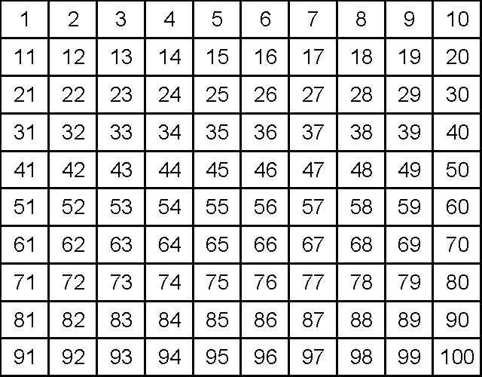
21+77=98
Start at the greater number. Move down to add ten and move to the right to add ones. If you come to the end of a row, continue in the next row. Do not count by ones only!

Student explanation: “I started with the greater number, 77. I moved down twice for the two tens and then to the right one space for the one one. I landed on 98.”

Base ten pieces
15+27=42

Draw each number using base ten pieces. If you can, group the units into ten. Count how many tens and units.

Student explanation: “I drew 15 and 27 using base ten pieces. I could group the units so that I had a group of ten and then two units leftover. I now have four tens and two units. My answer is 42.”
Number line
21+77=98
+1
+10
+10

77
98
97
87
Start with the greater number and use ten, five, and one hops to add on the other number.

Student explanation: “I started with the greater number, 77. I made two ten hops for the 20 and then one one hop for the 1. I landed on 98.”
Expanded form (tens and ones)
15+27=42
Tens Ones Tens + Ones

10+20=30 5+7=12 30+12=42
Add the tens place of both numbers together and then repeat with the ones. Then add those two numbers together.

Student explanation: “I started by adding the tens place 10+20=30 and then I added the ones place 5+7=12. When I added 30+12 I had four tens and two ones. My answer is 42.”

